ANUDEEP SIMHA REDDY 20BCE2495

1) Download tableau desktop & Mysql in your PC or laptop

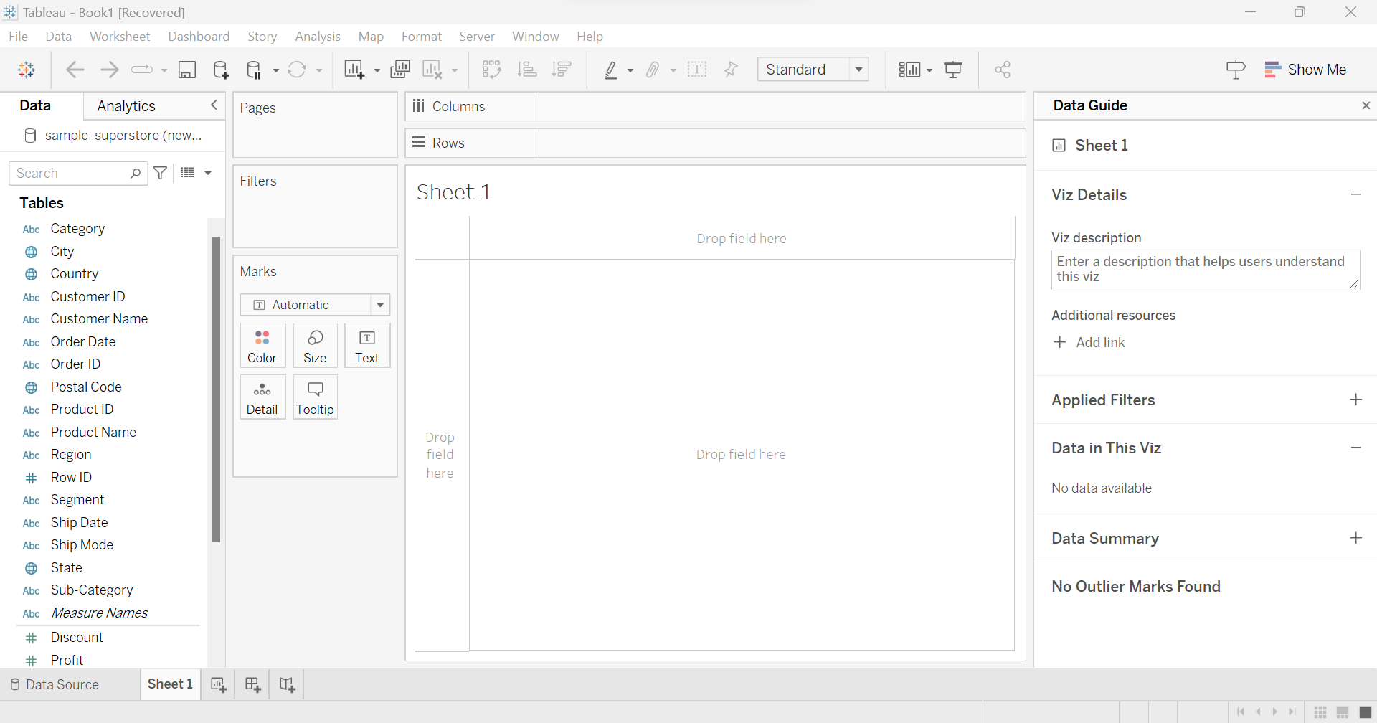

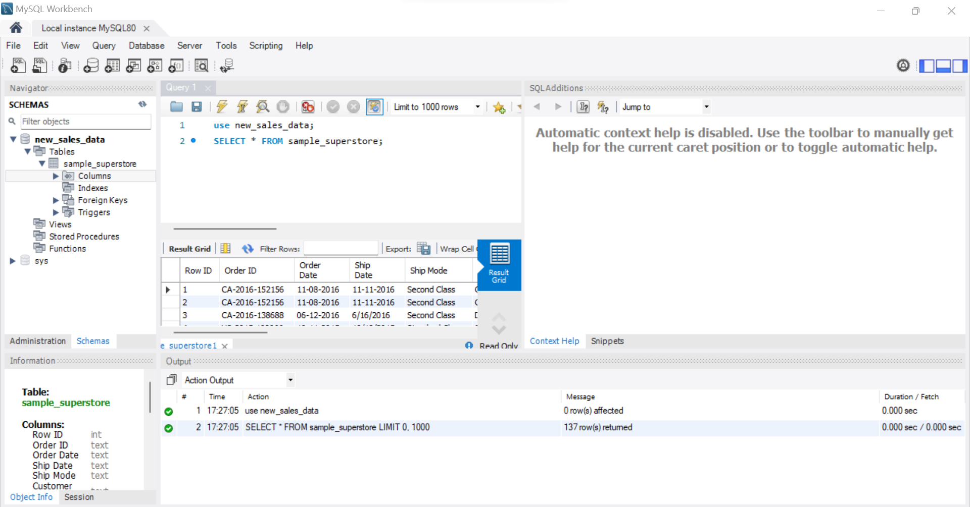

2) Create a new schema in your Mysql workbench and upload your data

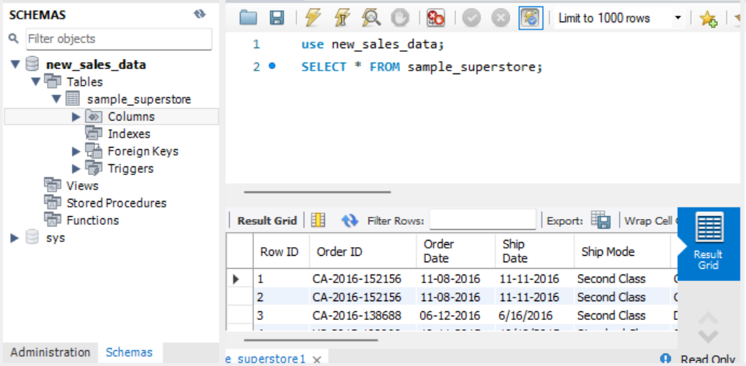

3) Connect your Mysql and Tableau

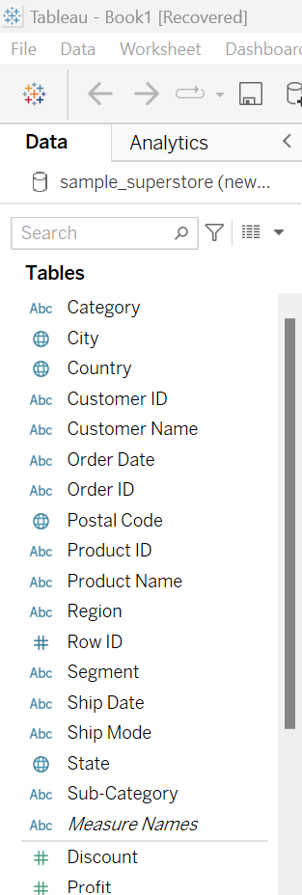  
4) Create the below 5 charts/plots  
● Bar chart

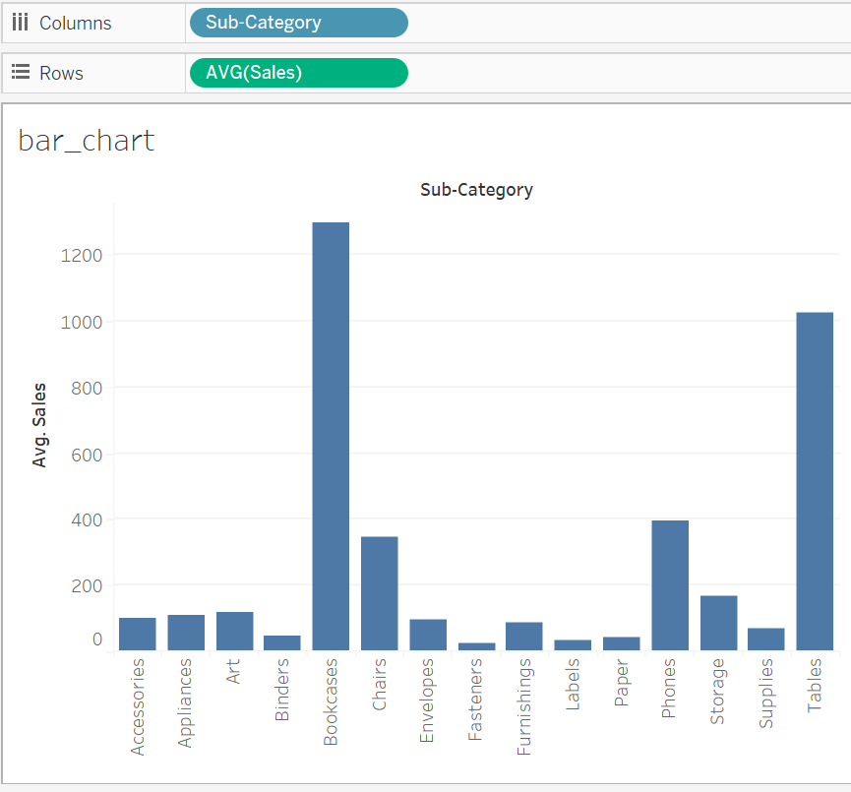

Bookcases category has the highest average sales and Fasteners has the lowest average sales  
● Tree map

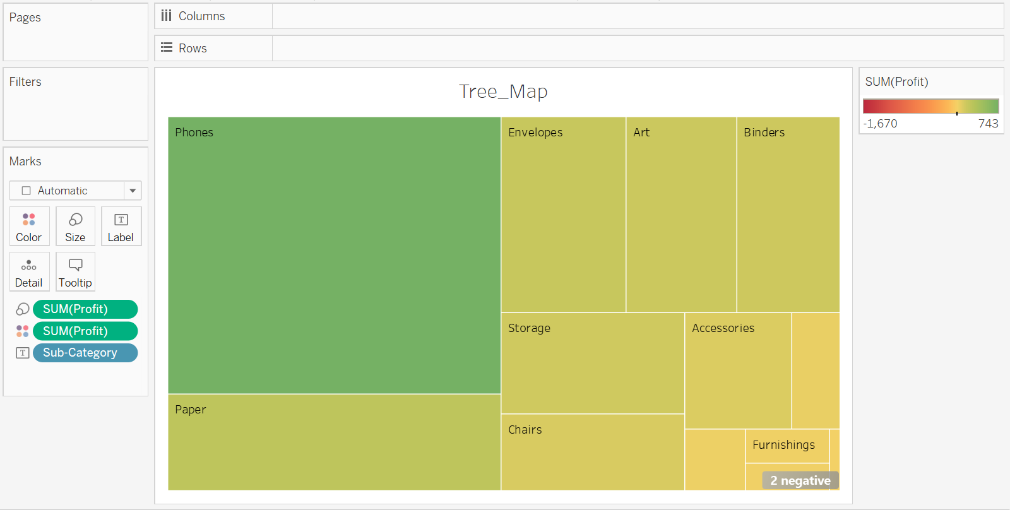

● Heatmap

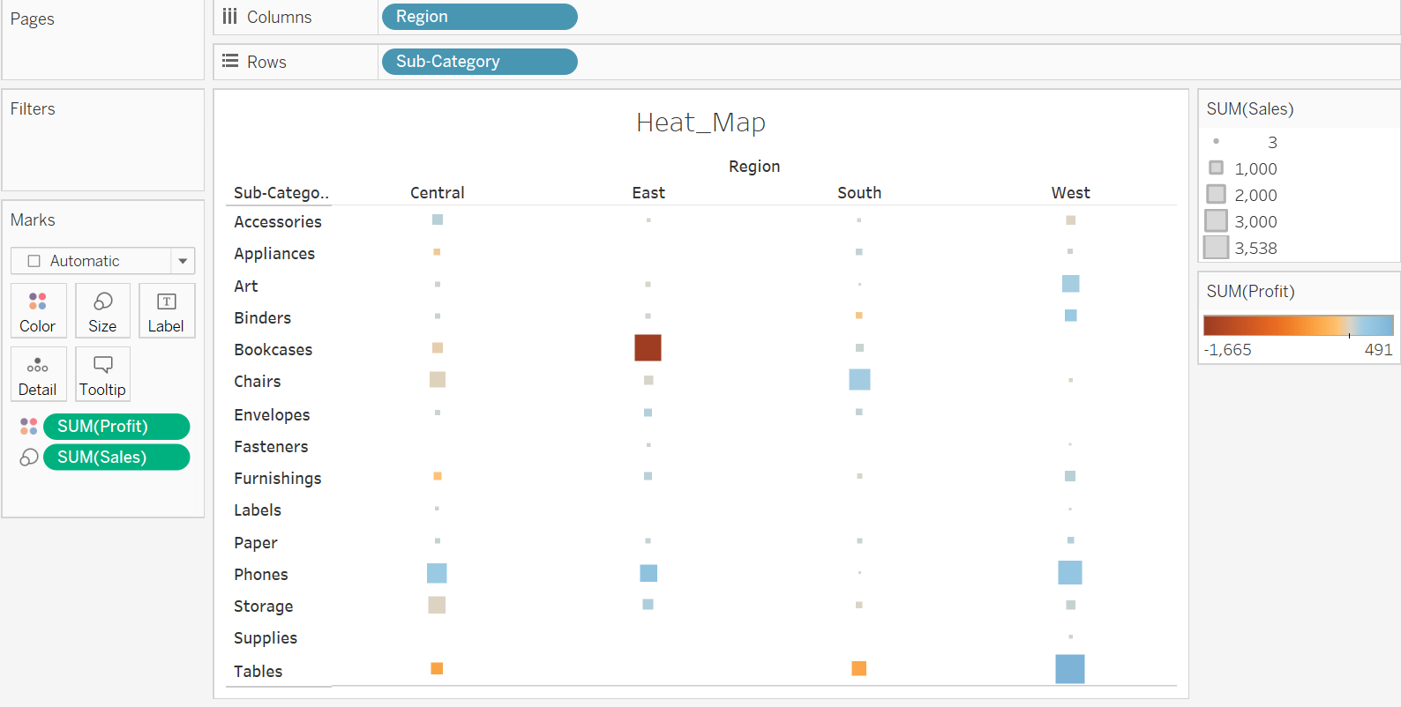

Tables have most profit in west region and bookcases have most loss in east region

Box size  
● Pie chart

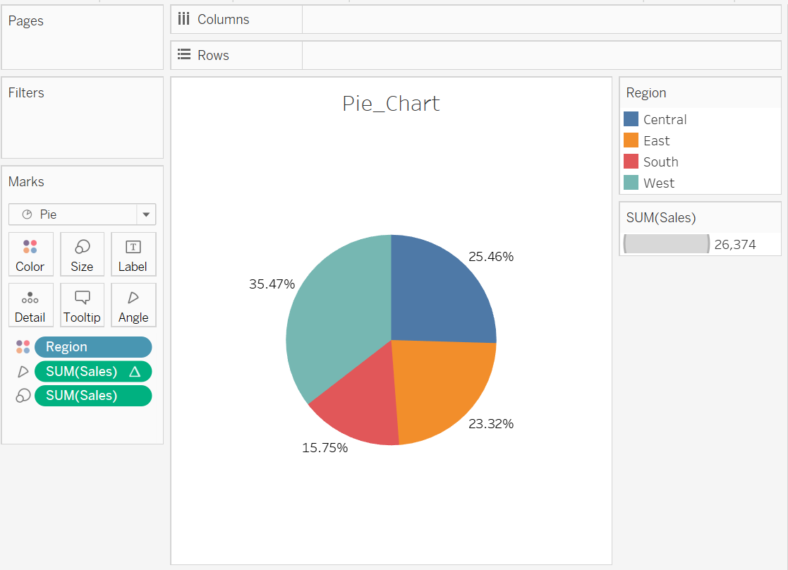

● Horizontal bar chart

